Project Submitted By

Name | College Name | Branch | Email | Expected Degree  Completion Year
Kshitij  Uddhav  More | Ajeenkya Dy Patil School Of Engineering (SPPU) | AI&DS | Kshitijmore551@gmail.com | 2027
Alakh  Tiwari | Ajeenkya Dy Patil School Of Engineering (SPPU) | ENTC | alakhtiwari7172@gmail.com | 2027

Project Code
FIP251

Project Name
House Price Prediction

Abstract
The House Price Prediction project is a machine learning application that predicts the sale price of houses based on various features such as area, number of rooms, location, and overall quality. The project uses historical housing data to train a machine learning model capable of estimating house prices accurately. The project follows a complete machine learning pipeline including data loading, preprocessing, feature engineering, model training, and prediction. Random Forest Regression algorithm is used to build the predictive model. The system processes housing features as input and generates predicted house prices as output. This project demonstrates the practical implementation of machine learning techniques for solving real-world regression problems in the real estate domain

Domain
Machine Learning, Data Science, Real Estate Price Prediction

Technologies Used
Python, Pandas, NumPy, Scikit-Learn, Matplotlib, Seaborn

Tools Used
Kaggle Notebook, Jupyter Notebook, Google Colab, VS Code

Project Link
Kaggle Notebook Link: https://colab.research.google.com/drive/1vXvhLL7gkyy0fpr0xWuiKqjW9yobzIH9

GitHub Link:
https://github.com/kshitijmore/House-Price-Prediction-ML

Instructions to run the project
1.Clone the Repository:
a. git clone: https://github.com/ommhaske73/om-mhaske.git
2.Install Required Libraries:
pip install numpy pandas matplotlib seaborn scikit-learn 3.Download Dataset:
Go to Kaggle → House Prices Competition → Download dataset Place these files in project folder:
- train.csv
- test.csv
- sample_submission.csv

4. Run the Project:
Open the notebook or Python file and run: python house_price_prediction.py 5. Model Training The program will:
- Load dataset
- Perform preprocessing
- Encode categorical features
- Train Random Forest model
6. Prediction
The trained model predicts house prices for test dataset.

7. Output File
A file named submission.csv is generated containing predicted house prices. This file can be uploaded to Kaggle competition.

Output Images / Screenshots :
Dataset loading screenshot: 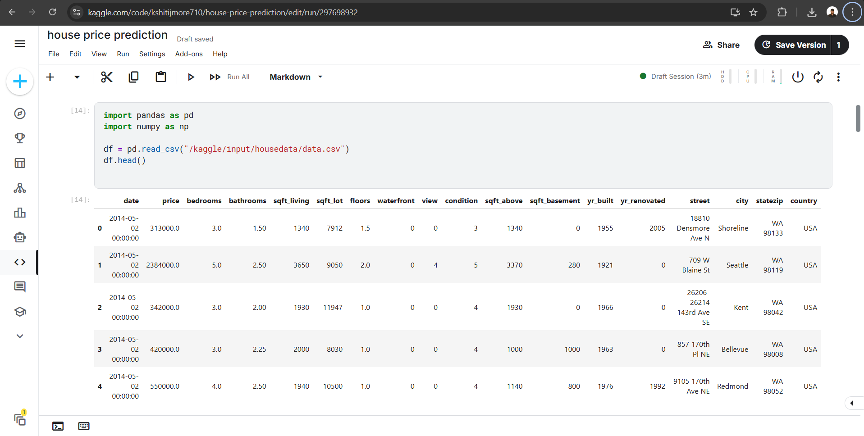

- Data preprocessing screenshot:
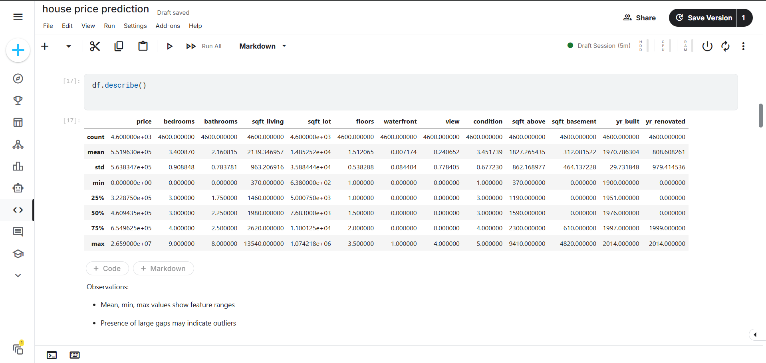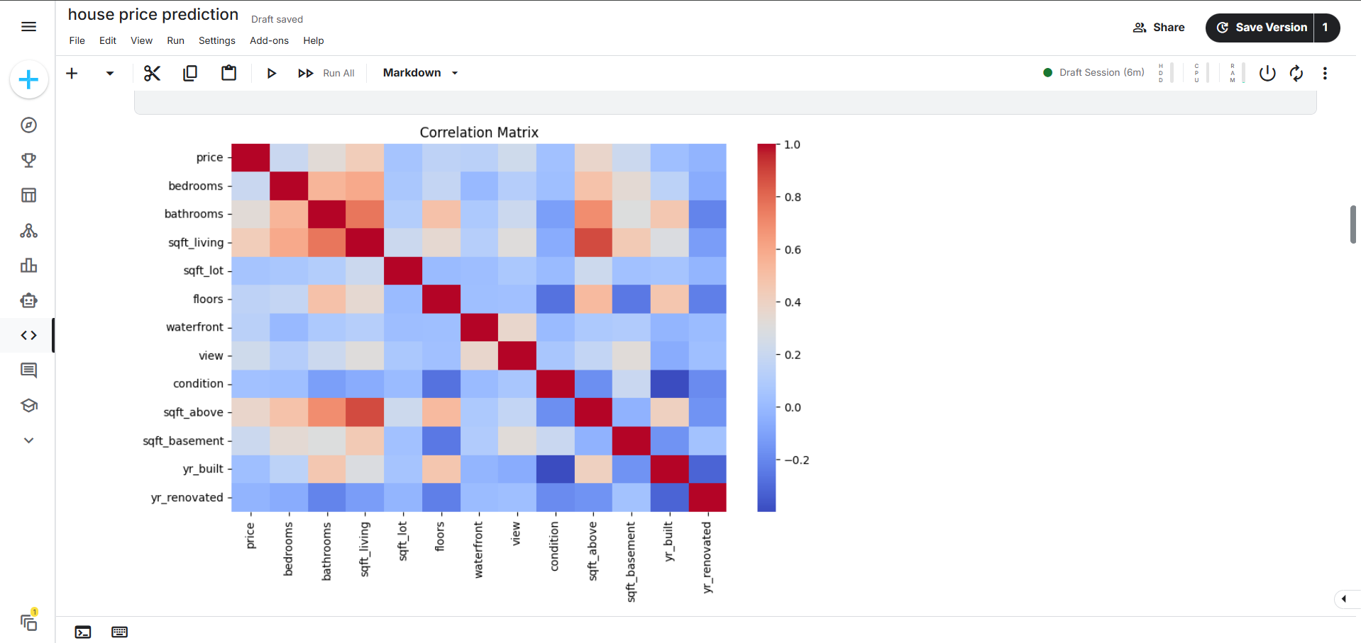

- Model training screenshot
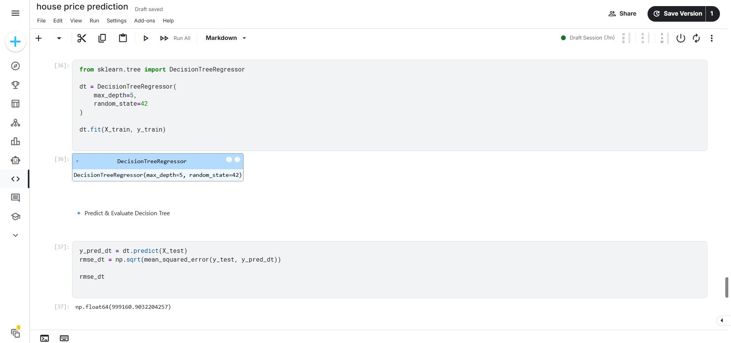

- Prediction output screenshot:
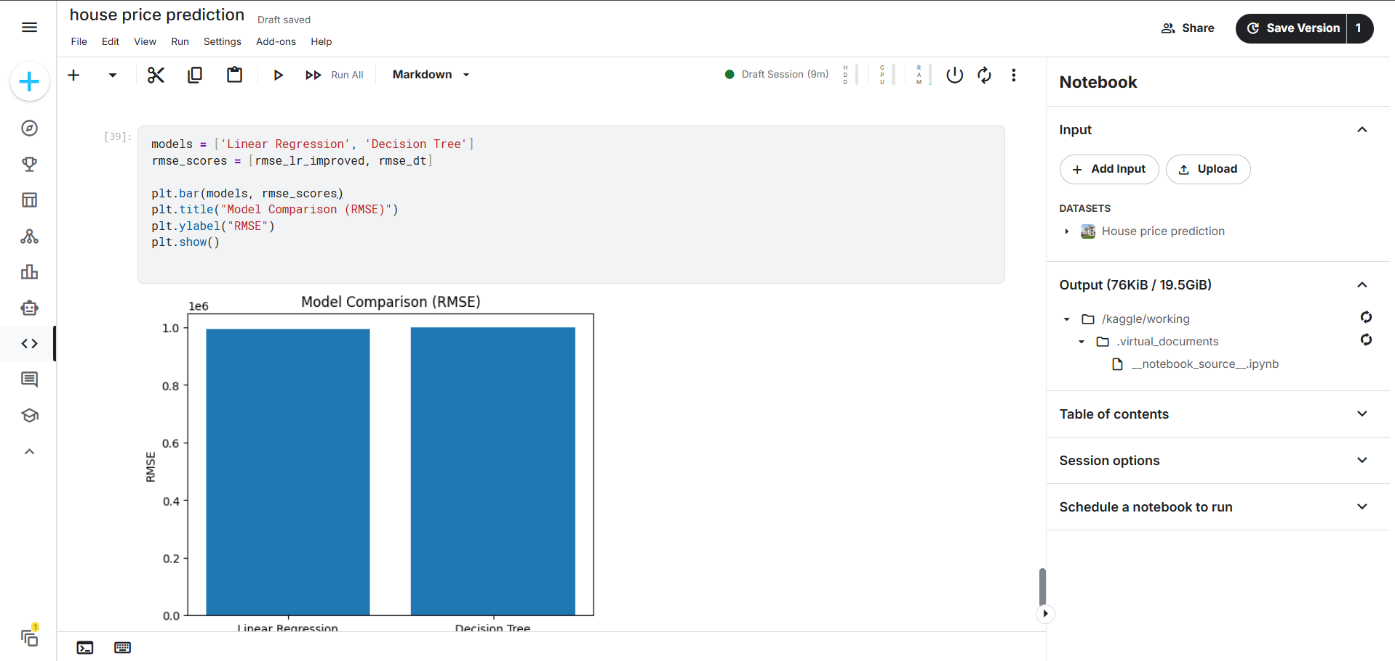

- Kaggle notebook screenshot:
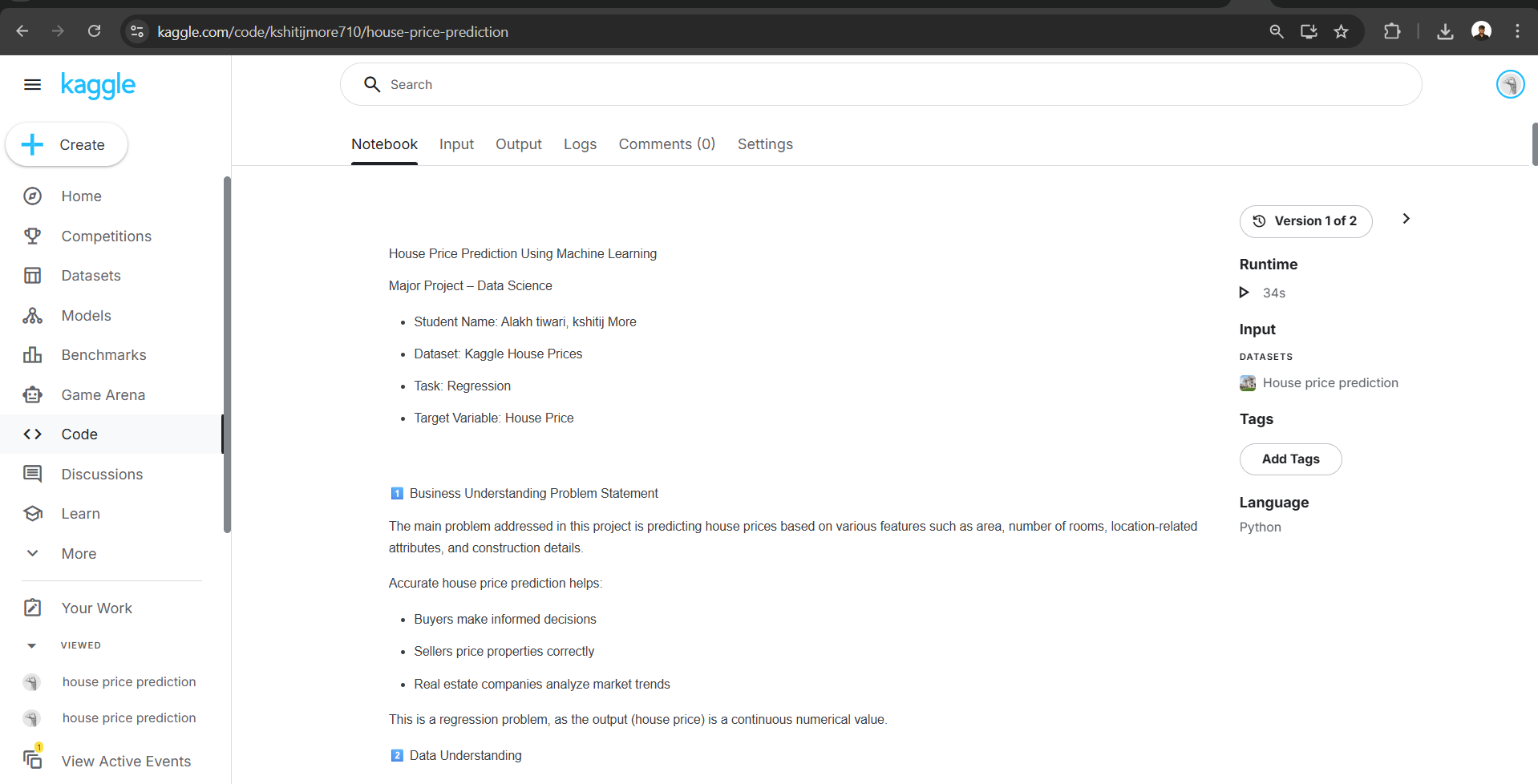

- GitHub repository screenshot:
